Software Requirements Specification
for
Start-up Initiative NU
Version 1.0 approved
Anirudh Kapoor
U101114FCS194
S 2

Table of Contents -
Table of Contents ii
Revision History ii
1. Introduction 1
1.1 Purpose 1
1.2 Document Conventions 1
1.3 Intended Audience and Reading Suggestions 1
1.4 Product Scope 1
1.5 References 1
2. Overall Description 2
2.1 Product Perspective 2
2.2 Product Functions 2
2.3 User Classes and Characteristics 2
2.4 Operating Environment 2
2.5 Design and Implementation Constraints 2
2.6 User Documentation 2
2.7 Assumptions and Dependencies 3
3. External Interface Requirements 3
3.1 User Interfaces 3
3.2 Hardware Interfaces 3
3.3 Software Interfaces 3
3.4 Communications Interfaces 3
4. System Features 4
4.1 System Feature 1 4
4.2 System Feature 2 (and so on) 4
5. Other Nonfunctional Requirements 4
5.1 Performance Requirements 4
5.2 Safety Requirements 5
5.3 Security Requirements 5
5.4 Software Quality Attributes 5
5.5 Business Rules 5
6. Other Requirements 5
Appendix A: Glossary 5
Appendix B: Analysis Models 5
Appendix C: To Be Determined List 6

Revision History
Name | Date | Reason For Changes | Version

Introduction

Purpose -
Basically the purpose of this portal are as follows:
- Firstly, we should be able to create a platform which connects startups with interested students, based on their skillset and experience.
- Secondly, allow students to find a co-founder for their startup or any help relating to their startup.
- And lastly allows all students to access vital information regarding placements, interviews and their criteria’s.

Document Conventions – There are no conventions used.

Intended Audience and Reading Suggestions -
The intended audience is university faculty, placement cell, students, testers and marketing staff. There are no specific reading suggestions for this document.

Product Scope – In this the software contains basically all these stuffs which are :

Create a platform which connects startups with interested students, based on their skillset and experience.
- Experience before graduating from university is what every company looks for nowadays. Likewise, many startups are looking for skilled engineering students to help them out. This gap is what this software intends to bridge.

Allow students to find a co-founder for their startup or any help relating to their startup.
- It is very critical to find a cofounder and even more so to get help from experienced members of this college. This is what this software intends to help an entrepreneurial student do.

Allow students to access vital information regarding placements, interviews and their criteria’s.:
- The benefits of this software feature are students getting better knowledge of the criteria’s relating to placements and interviews, the types of questions asked and the minimum requirements for different companies that visit the campus, thus increasing the chances of a student getting a job immensely.

References- No references.

Overall Description

Product Perspective – Basically it deals with the problems coming in day to day life while handling this software by the users which are :
This document contains the description of a software solution for solving 3 critical issues faced by university students: Help university students in placement interviews, providing a platform to meet cofounders and seek help for startup and Bridging the gap between startups and students seeking internship opportunities.
The website will have a user log-in system (both native and social network log-ins) and would have the feature of user profiles, wherein the users can display their skills, job experience, startups and other relating information.
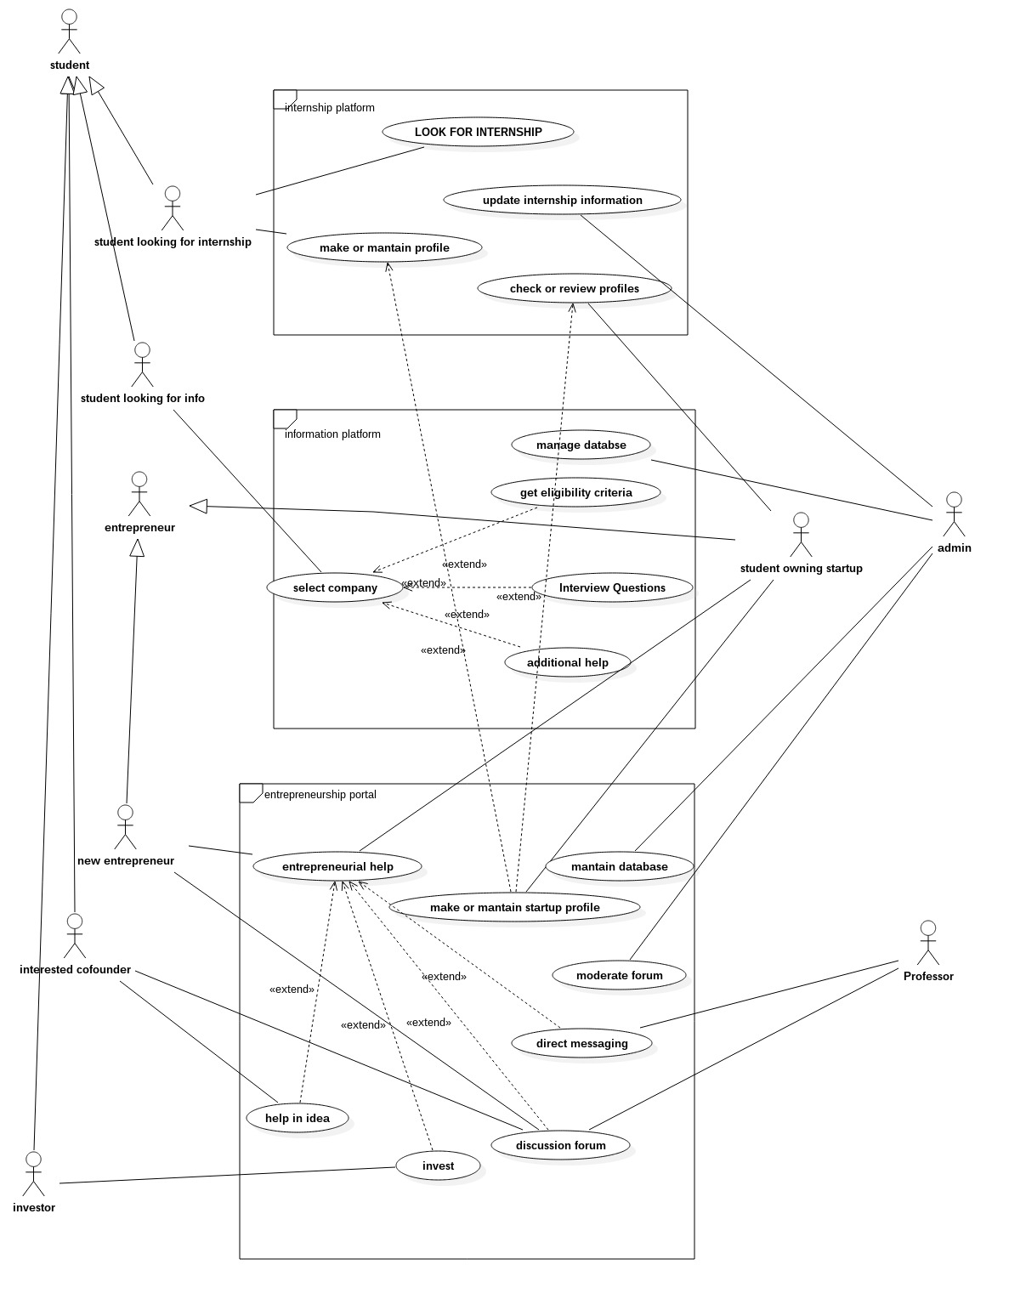
It will have a notification feature for various types of user-notifications.
Along with this, it’ll also feature Direct-Messaging feature for inter-user communication and email notifications on the registered mail.

Use Cases | Objects | Description
UC1 | Look for internship | Allows user to search from the list of live internships
UC2 | Update internship information | update the details of the internship
UC3 | Make or maintain profile | Create or edit profile details of the user
UC4 | check or review profiles | check profile details of users
UC5 | Select company | User may chose a company for details
UC6 | Manage database | Allows admin to manage the database
UC7 | get eligibility criteria | Allows user to get the eligibility criteria for jobs at listed companies
UC8 | Interview question | Allows user to browse interview question asked at different company interviews
UC9 | additional help | Allows user to ask for additional help
UC10 | make or maintain startup profile | startup owners can create mantain profiles of their firms wherein they can also view profiles of students
UC11 | maintain database | the administrator constantly needs to alter the information there in the database to keep it afloat.
UC12 | moderate forum | the administrator can check users for their inappropriate behaviour and penalize them accordingly.
UC13 | direct messaging | teachers and students can directly message each other regarding a doubt/problem.
UC14 | help in idea | a person willing to be a cofounder of an entrepreneurial startup, can now start interacting with his co immediately
UC15 | discussion forum | a common platform for sharing knowledge.
UC16 | invest | enables a willing investor to invest in a startup of his choice

Product Functions -
This product has 3 main features:
- Provide help to university students for placement interviews
- Provide a platform for university students to find cofounders and seek help for startup
- Bridging the gap between startups and students seeking internship opportunities

Major Functions of the website:
- Authenticate and Login user to the website.
- Enable new users to register to the Website.
- Enable a registered user to change his password in case She/he forgets Hers/his password.
- Enable a registered user to view his/her profile. Additional information viz. questions asked by him and answers posted by him are also displayed.
- Enable a registered user to update his profile which includes her/his location, skills and profile picture.

- Enable a user to view available internships
- Enable a logged in add skills
- Enable a logged in user to Add a Start-up profile.

User Classes and Characteristics – It contains basic 3 features which are :
- First is the student ,
- Second the faculty and
- Lastly the administrator of the system
- It is necessary for the user to have a basic knowledge of operating the internet and have an access to it.
- The administrator is expected to be familiar with the interface of the tech support system.

Operating Environment -
Chrome, Firefox, IE and Tor or any other modern browser supporting HTML5 and JavaScript.

Design and Implementation Constraints -
This system is provisioned to be built on the Django framework which is highly flexible. Decision regarding which database to use should be taken considering the fact that data being exchanged or stored is large, and the appropriate data management system will yield efficient performance.

User Documentation - No user documentation required.

Assumptions and Dependencies -

This software depends on the type and version of browser being installed in the system i.e. The browser version being used must have HTML5 and JavaScript support.

External Interface Requirements

User Interfaces -
Each interactive part of software is made to be understandable and efficient for user. The software will be kept light so it does not take time to load and can handle large number of users properly

Hardware Interfaces -
A working Computer. The software will perform optimally with a System having 1 gb or more Ram and Intel Core2duo Processor or better.

Software Interfaces -
Front End: JS and CSS
Back End: Django
Database: Mongo DB

Communications Interfaces -
When the task is fully created an e-mail should be sent to the customer with detailed information about the module.

System Features
By the help of system features basically one can classify all these as follows :

look for internships.

May get an overview , idea of companies visiting the university and their recruitment notices.

Students aiming towards their own startups shall now have a platform to interact with those interested in supporting/financing.

The “entrepreneurship help” platform shall solely deal with entrepreneurs who already have a startup functioning.

This will be to link coaches, teacher, tutors, mentors and entrepreneurs, to increase the availability and free flow of knowledge. Other Nonfunctional Requirements
Feature 1 -

A: Feature aims to extract knowledge from conventional internship providers for students as well as to have the flexibility of being accessed by the providers as well to choose and recruit students best fit for their job. This is eliminative feature of this company.

A similar flexibility is provided to the students as well , who may choose from a variety of employers , whom to work with.

Priority : 9 (High)
Being the backbone of the entire software, this is most needed.

Cost of development- medium

Risk : low

Benefit : considerable

Sequence of user actions - Following are the requirements which are as follows :
Functional Requirements -

    - Java Runtime Environment
    - Internet Browser
    - Operating System
    - MS .net Framework
    - CISCO PEAP module
    - MS Visual Cpp 2005 redist.

Feature 2: Placements -

This feature is going to be another very interesting component of our software package.This will primarily be dealing with campus placements and industry practices.

- This feature shall contain 3 main sub features, as we may call them, namely:
Aptitude/General question sets.
- Tutorials/Expert advise from volunteering teacher
- Recruiting companies, Eligibility Criteria vise.

Sequence of user actions -

Feature 3: Startups platform -

This feature aims at helping students who have come up , or wish to come up with start ups of their own.

The most adventurous thing that has been planned about this component is that it shall allow student owning startups , to create/maintain a profile of their companies. Further, it shall also allow the owner to view the profiles of students interested in working as interns in their startups.

This feature provides functionality to two types of users, ones who have already come up with startups, and the ones who wish to do the same in near future.
    - The forum enables the idea of the start up to be circulated throughout the members.
    - Members interested in refining/investing in the idea may come forward and contact the person who conceived it.
    - The forum also serves as a floor for all discussions, both in favor and against the idea, thus providing for a pre analysis , before actual execution.

Entrepreneaureal Help -
      - This no doubted is the most salient feature of the startups platform.
      - This is going to enable students to interact with existing entreaupreneaurs, tutors and mentors, who can reinforce young ideas further with their experiences.

Tabulated form :
Identifier | Short name | Short description

Student looking for an internship | Internship platform | Allows users to maintain profiles that can be viewed by employers, for internships.  Allows users to choose from among different internships as well.
Student looking for information | Information platform | This feature allows the user , to search for a company they would like to work for.  Content is supposed to include practice tests , general interview questions, eligibility criteria, paycheck information, etc.
 | Entrepreneurship platform | This , is probably the most ambitious portion of our project.  This sytem aims to provide entrepreneurial help to people by facilitating both forum interaction and person to person profile interaction.  Students , mentors , teachers can all be a part of the system , in addition to people interested in co conceiving , or financing the startup
  Student looking to conceive a startup. | Entrepreneur with an existing startup

Other Requirements

Performance Requirements -
This portal will be hosted on a server that could provide decent response time.
College students give short attention time , therefore a weak server will not be good enough for the application.
Compatibility and optimizations are going to be better than that for NU Moodle.

- 32-bit OS.
- Intel Dual Core processor
- Atleast 512 MB RAM

Safety Requirements - No such safety requirement till now.

Security Requirements -
Copyright of the portal will be with the developers of the portal and NIIT University.
The website will be encrypted to ensure security.

Software Quality Attributes –
- Image to text conversion.

- History of searched data , that will help in making the product robust.

- Easy to use interface.

- Usage of efficient algorithm.

<Specify any additional quality characteristics for the product that will be important to either the customers or the developers. Some to consider are: adaptability, availability, correctness, flexibility, interoperability, maintainability, portability, reliability, reusability, robustness, testability, and usability. Write these to be specific, quantitative, and verifiable when possible. At the least, clarify the relative preferences for various attributes, such as ease of use over ease of learning.>

Business Rules -
<List any operating principles about the product, such as which individuals or roles can perform which functions under specific circumstances. These are not functional requirements in themselves, but they may imply certain functional requirements to enforce the rules.>

